
MODUL 13 PERKULIAHAN 2025

English for General Purposes

Fakultas | Program Studi | TatapMuka | Kode MK | KELAS |   DisusunOleh  Drs. Budiantoro, MA
FEB | Program  AKUNTASI & MANAJEMEN | 13

Abstract Transportation and vehicles vocabulary words in English with useful list and pictures. Knowing how to talk about various types of transportation is a huge advantage when leaning to speak English.

Competency Students are able to understand, first, the vocabulary by listening, speaking, reading and writing from general resources of Vocabulary the student able to make presentation about the topics below:

- Transportation in Indonesian
- Land transportation or land transportation
- Air transportation
- Water transportation
- Tell about the fare

TRANSPORTATION IN INDONESIAN
Transportation is a means of transportation, conveyance, or vehicle. In this article, we will discuss various kinds of vocabulary about vehicles or means of transportation that we must have often found or even used in everyday life.

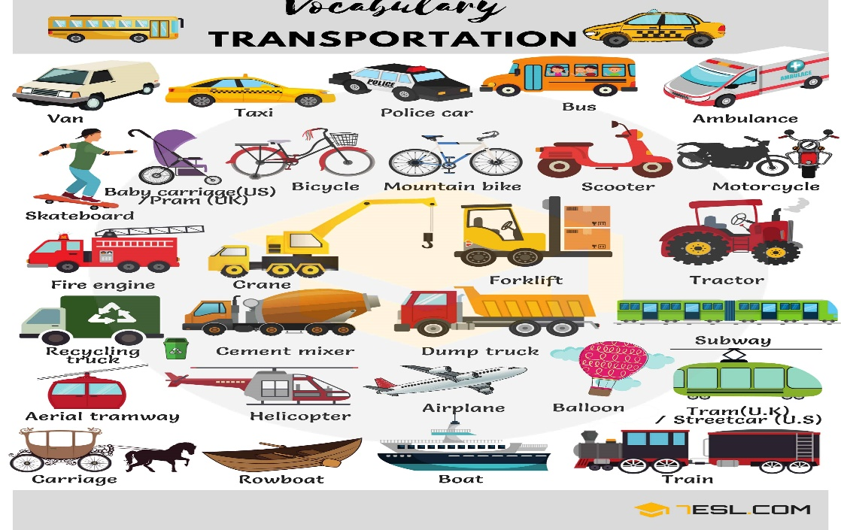
Transportation is divided into three models, namely land, air and air transportation. We will discuss one by one the vocabulary about transportation that belongs to that category. Read carefully the following vocabulary with example sentences:
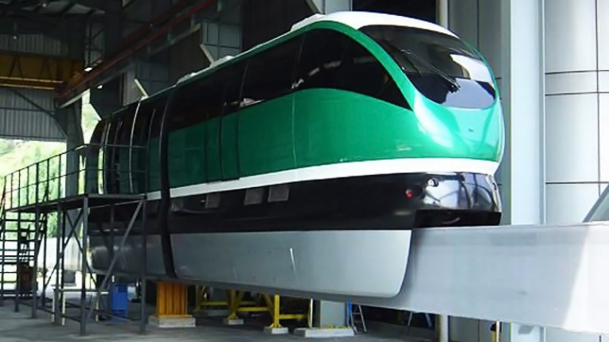
How is Indonesia suddenly capable of building its own high-speed train? - Quora

Land transportation or land transportation
Land or land transportation is land transportation, which is a tool or vehicle used to move living things and inanimate objects from one place to another by road (road) or rail (train).
Vehicles included in land transportation include:
• Cars)
• Bicycle (bike)
• Motorcycles (motorcycles)
• Train (train)
• Bus (bus)
• Trucks (trucks)
• Becak (rickshaw)
Let's see if each of these words is used in a sentence:
• My father drives me to school in his car (Father takes me to school in his car).
• A bicycle with only one wheel is called a unicycle (a bicycle with only one wheel).
• Gasoline-fueled motorcycles (Gasoline-fueled motorcycles).
• This train has seven locomotives (This train has seven engines).
• A night bus crashes into another car on the highway (A night bus hits another car on the expressway).
• Garbage trucks dump their contents into landfills (Garbage trucks dump their contents into landfills).
• Mother goes to the market by rickshaw (Mother goes to the market by rickshaw).
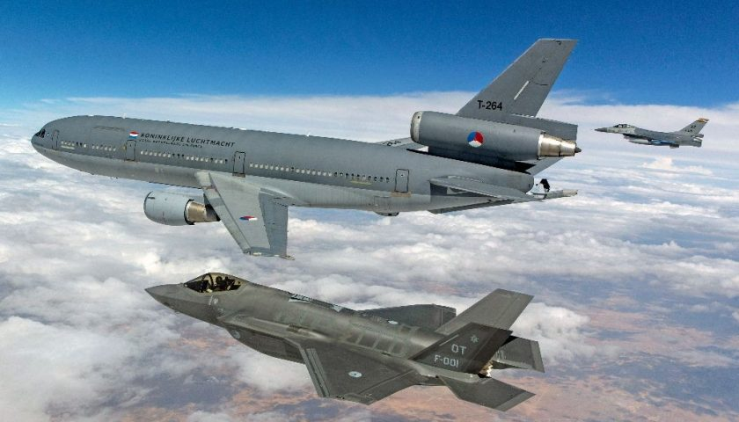
Indonesia weighs acquisition of Russian Su-35s to obtain American F-35s - Meta-Defense.fr

Air transportation
Air transportation is a means of transportation that uses a machine so that it can fly at a certain height and is also used to carry passengers or goods. Some of the types of vehicles in the air are:
• Airplanes (aircraft), passenger aircraft (airplanes with passengers), cargo aircraft (planes for moving goods over long distances quickly), and fighter aircraft (aircraft used by the air force).
• Helicopter (helicopter)
• Spaceships (space vehicles)
• Hot air balloon (blimp)
Examples of sentences that use the vocabulary of types of vehicles in the air are as follows:
• The plane leaves at 8 (The plane leaves at 8 sharp).
• Helicopters are also used as Search and Rescue vehicles (Helicopters are also used as search and rescue vehicles).
• Soyuz is a Russian spacecraft, first built in the 1960s (Soyuz is a Russian spacecraft, first built in the 1960s).
• Hot air balloon tour is a unique attraction in Cappadocia, Turkey (Baloon ride tour is a unique attraction in Cappadocia, Turkey.
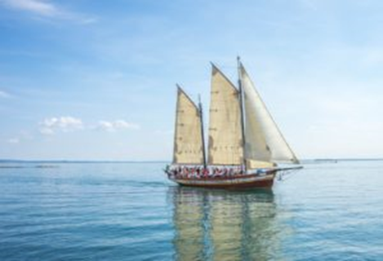

Water transportation
Water transportation is also known as sea transportation, namely transportation that transports passengers (passengers) or goods (cargo) by air. Water transportation is also often used for short trips and cruises.
Some types of water transportation that are familiar to our ears are:
• Boat (boat)
• Ship (ship)
• Sailboat (sailing boat)
• Cargo ship (cargo ship)
• Submarine (submarine)
• Speedboats (fast motorboats)
• Naval ships (warships)
Let's try the vocabulary about water transportation above the sentence:
• This boat can only carry two people at a time (This boat only carries two people at a time).
• Titanic was the largest ship of her time (Titanic was the largest ship of her time).
• A sailboat can sail against the wind (A ship can sail against the wind).
• Tanker is a type of cargo ship used to transport oil (Ship is a type of cargo ship used to move oil).
• Submarines can be submerged for months (Submarines can be underwater for months).
• Andi can't ride a speed boat well (Andi can't ride a speed boat well).
• The oldest naval ship in history built in 1765 (The oldest warship in history was built in 1765).

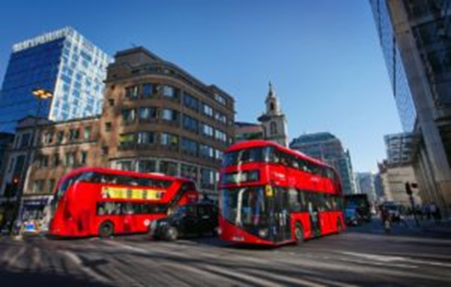

No |  | English | Indonesian
1 | Bus  (bus) | Hi, where did you spend last school vacation? | Halo, kawan, kamu kemarin liburan sekolah kemana saja?
 |  | I visited my grandma in Sleman | Aku mengunjungi nenekku di Sleman
 |  | That is interesting | Menarik sekali
 |  | How long was it? | Berapa lama kamu tinggal di sana?
 |  | It was less than two weeks, I think | Kayaknya kurang dari dua minggu, deh
 |  | What about you? | Kamu sendiri bagaimana?
 |  | Where did you go? | Kamu pergi ke mana liburan kemarin?
 |  | I spent my holidays in Surabaya; visiting my parents | Aku pergi ke Surabaya, mengunjungi orang tuaku
 |  | How are they? | Bagaimana kabar mereka?
 |  | They are fine, thanks for asking | Mereka baik-baik saja, terima kasih sudah bertanya
 |  | How did you get there, by the way? | Omong-omong, bagaimana caranya kamu bisa tiba di sana?
 |  | I traveled using bus | Aku pergi menggunakan bus
 |  | I went to Sleman by bus, too. | Aku ke Sleman naik bus juga, lho
 |  | How much was the fare from Solo, my friend? | Ongkos bus ke sana dari Solo berapa, teman?
 |  | It was ten thousands rupiah from Solo, and I made stop at Adisucipto International Airport first | Dari Solo ongkosnya 10 ribu rupiah, dan pertama-tama aku turun di Bandara Internasional Adisucipto
 |  | So, it was not a simple trip? | Jadi, perjalanannya nggak sederhana, ya?
 |  | It wasn’t, and I continued the trip using another public transportation called Jogja Trans | Nggak juga, dan aku melanjutkan perjalanan dengan alat transportasi umum lainnya yang disebut Jogja Trans
 |  | Oh, yeah? How much was the ticket? | Oh, ya? Ongkosnya berapa?
 |  | My grandma stays in Kaliurang neighbourhood, next to Gajah Mada University and I got there with only 3500 rupiah | Nenekku tinggal di kawasan Kaliurang, bersebelahan dengan Universitas Gajah Mada dan aku tiba di sana hanya dengan ongkos 3500 rupiah
 |  | That will be nice | Menarik sekali
 |  | So, I stopped at Jogja Trans bus shelter at Kopma UGM and took a walk to her house | Jadi, aku turun di shelter bus Jogja Trans di Kopma UGM dan berjalan kaki ke rumahnya
 |  | Is your grandma’s house near to Sultan Palace? | Apa rumah nenekmu dekat dengan Istana Sultan?
 |  | Not really, but it is only 30 minutes using Jogja Trans due to traffic | Nggak juga, tapi lokasi itu hanya 30 menit menggunakan Jogja Trans dan itupun lama gara-gara macet saja, kok
 |  | Would you tell me about the Jogja Trans, my friend? | Kamu mau kan menceritakan padaku tentang Jogja Trans, kawan?
 |  | It is public transportation similar to busway in Jakarta, on which people can circling around Yogyakarta, where they can only stop at bus shelter or a place called portable | Itu transportasi umum yang mirip dengan busway di Jakarta, kok, dan orang bisa berkeliling Jogja sembari menaikinya dimana mereka hanya bisa berhenti di shelter bus atau tempat yang disebut dengan portable
 |  | The buses are smaller than those in Jakarta, but they are okay | Busnya sendiri berukuran lebih kecil ketimbang yang di Jakarta, tapi bagus kondisinya, kok
 |  | I do want to visit Sultan Palace, may I join you when you go to Yogyakarta next time? | Aku ingin sekali mengunjungi Istana Sultan, boleh nggak aku ikut denganmu nanti kalau kamu ke Jogja?
 |  | Sure, just go with me and stay at my grandma’s house | Tentu saja, ikut saja denganku dan tinggal di rumah nenekku saja
 |  | The Sultan Palace is near to Beringharjo Market, where you can find the mouthwatering sate kere and any traditional snacks | Istana Sultan lokasinya dekat dengan Pasar Beringharjo, dimana kamu bisa menemukan sate kere yang lezat itu dan berbagai jajanan tradisional lainnya
 |  | That will be lovely, dude, thank you | Menyenangkan sekali, kawan, terima kasih ya
2 | Ship  (kapal laut) | Excuse me, would you tell me another way to arrive in Lombok instead of using airplane from Bali, please? | Permisi, bisakah Anda memberi tahu pada saya cara lain untuk sampai di Lombok dari Bali selain menggunakan pesawat terbang?
 |  | I am sorry, it seems that ship or small boat is the only that left | Mohon maaf, kalau begitu sepertinya pilihan Anda tinggal di kapal laut atau boat
 |  | It is okay, I can go with it | OK, saya sanggup menaikinya, kok
 |  | Where should I start my trip from Bali to Lombok, then? | Jadi, kalau begitu, bagaimana saya harus memulai perjalanan ke Lombok dari Bali?
 |  | Well, based on my experience, you need to go to Padang Bai Port or Nusa Penida first, then you can continue using ship or boat | Hmm, berdasarkan pengalaman saya, pertama-tama Anda harus ke Pelabuhan Padang Bai atau Nusa Penida, lalu Anda melanjutkan dengan kapal laut atau boat
 |  | So, I have two options? | Jadi, saya punya dua opsi?
 |  | You’re right | Ya, Anda benar
 |  | The difference is that if you use Nusa Penida, then you will arrive at Senggigi Beach, while Padang Bai Port will bring you to Port Lembar | Bedanya, kalau Anda menggunakan jalur Nusa Penida maka Anda akan turun di Pantai Senggigi, sementara kalau lewat jalur Pelabuhan Padang Bai maka Anda akan turun di Pelabuhan Lembar
 |  | What is the differene anyway? | Omong-omong, apa bedanya?
 |  | Quite a lot of differences, miss | Cukup banyak, nona
 |  | It takes 4 hours from Padang Bai to Lembar with only 46 thousands rupiah ticket per person, and it is quite difficult to arrive in downtown Mataram from Lembar | Perlu 4 jam dari Padang Bai ke Lembar dengan biaya cuma 46 ribu rupiah per orang, dan cukup sulit tiba area kota Mataram dari Lembar
 |  | On the other hand, Nusa Penida Port will bring you faster and more comfortable trip, less than 2 hours, with more money on it, about hundreds of thousands rupiah, and it is easier to go to downtown Mataram from Senggigi where Senggigi itself is not a port, but a beach, a beautiful beach | Di sisi lain, Pelabuhan Nusa Penida akan memberikan perjalanan yang lebih cepat dan lebih nyaman, kurang dari 2 jam, dengan ongkos lebih banyak, mencapai ratusan ribu rupiah, dan jauh lebih mudah tiba di area kota Mataram dari Senggi; di sisi lain Senggigi bukanlah pelabuhan, melainkan sebuah pantai, pantai yang sangat indah
 |  | Is the ship or boat okay? | Apakah kapal laut atau boatnya memiliki kondisi baik?
 |  | Sure, you will have nice ride on both choices | Tentu saja, kedua pilihan itu nyaman untuk dinaiki, kok
 |  | Thanks for your information | Terima kasih atas informasinya
 |  | You are welcome | Terima kasih kembali
3 | Car  (mobil) | I am afraid I can’t arrive at office on time today | Saya khawatir tidak dapat tiba di kantor tepat waktu hari ini
 |  | What happen, bro? | Ada apa, teman?
 |  | I am caught in traffic and I have troubles with my car | Saya terjebak kemacetan dan mobil saya bermasalah
 |  | Have you called mechanic? | Sudah memanggil montir?
 |  | Yes, I have | Ya, sudah
 |  | But, I park my car away from here | Tapi, saya memarkir mobil jauh dari sini
 |  | I don’t think it is a problem | Saya rasa itu tidak masalah
 |  | Just let the mechanic know the location | Cukup beritahukan saja lokasi pada montirnya
 |  | Oh, OK, then | Oh, baiklah kalau begitu
 |  | Thank you | Terima kasih
 |  | You are welcome | Terima kasih kembali
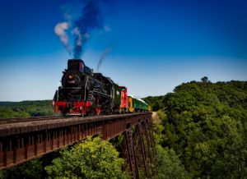
Transportation – Related Words
No | English | Indonesian
1 | Airplane | Pesawat
2 | Train | Kereta
3 | Bus | Bis
4 | Car | Mobil
5 | Motorcycle | Motor
6 | Bicycle | Sepeda
7 | Tricycle | Sepeda Roda Tiga
8 | Pedicab | Becak
9 | Taxi | Taksi
10 | Truck | Truk
11 | Scooter | Skuter
12 | Boat | Perahu
13 | Ship | Kapal
14 | Helicopter | Helikopter
15 | Hot-Air Balloon | Balon Udara
16 | Cable Car | Kereta Gantung
17 | Ambulance | Ambulans
18 | Submarine | Kapal Selam
19 | Subway | Kereta Bawah Tanah
20 | Tractor | Traktor

TUGAS JAWAB MINTA CHATGPT UPLOAD
  - Explain the main characteristics of Industry 5.0 and how it differs from Industry 4.0.
  - Describe the role of digital libraries in modern education.
  - Explain three advantages of digital libraries compared to traditional libraries.
  - Explain how robots assist humans in Industry 5.0.
  - Describe the three main types of transportation discussed in the module.
  - Explain why metadata is important in digital libraries.
  - Using an example, explain how passive voice is commonly used in academic or technical contexts.
  - Explain the importance of transportation in daily life and economic activities.
  - Explain conditional sentence type 1 using the context of digital libraries or Industry 5.0.
  - Describe a travel experience using public transportation based on the module.

